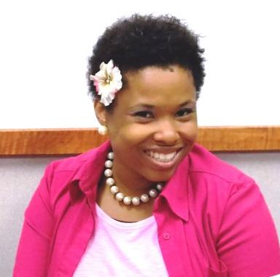
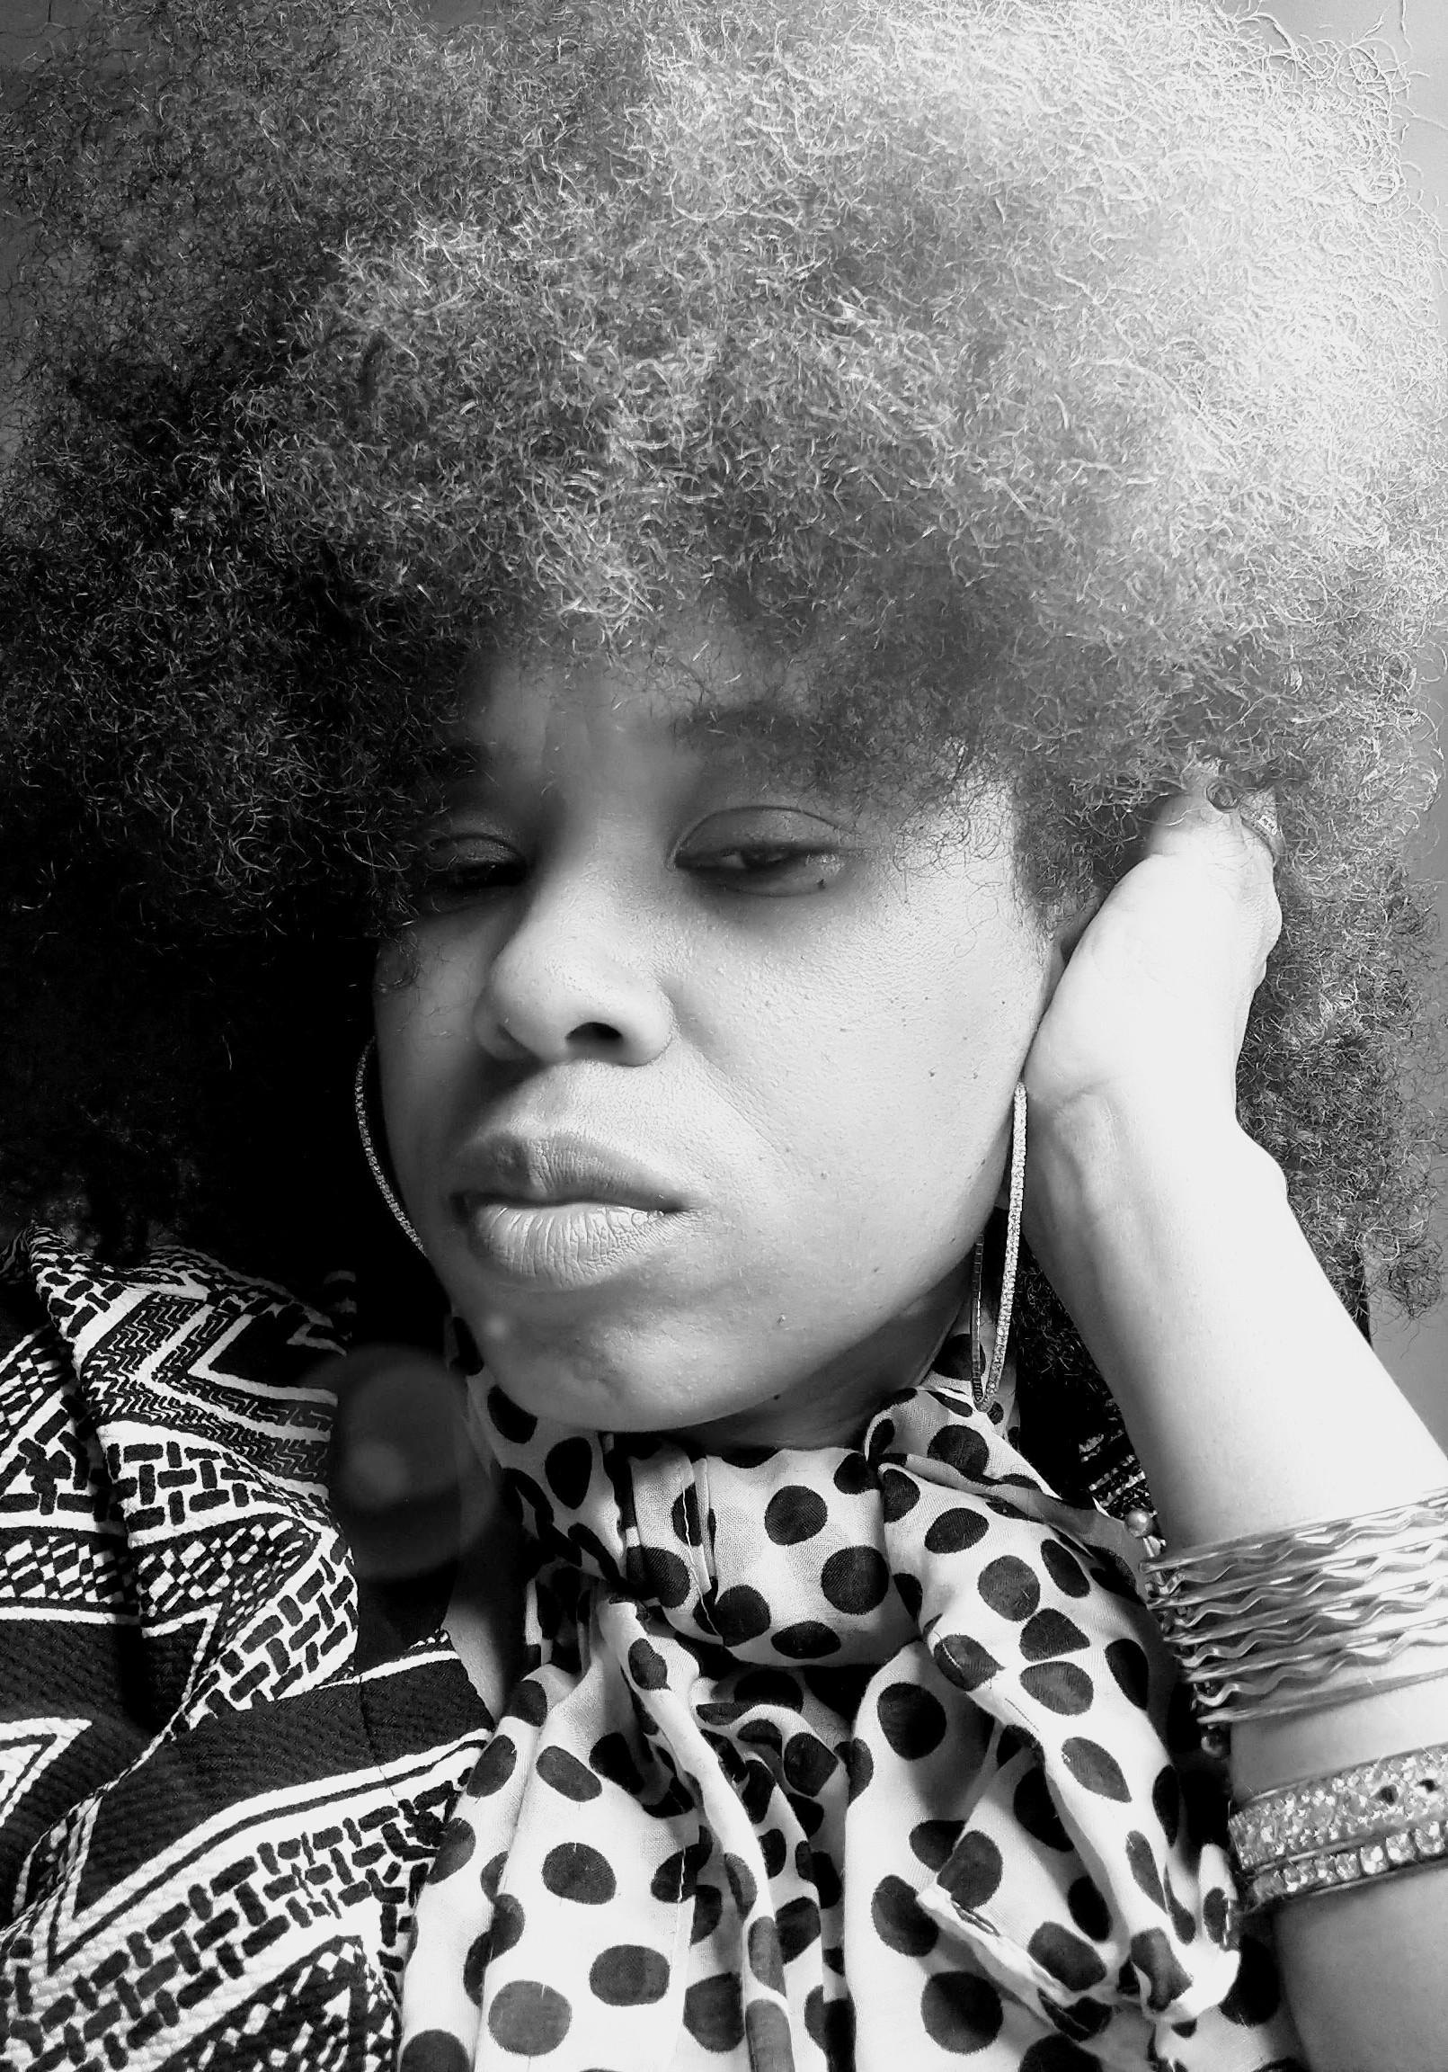Willetta J. Davis
Willetta J. Davis is a poet, spoken word artist, author and actress. She has appeared in community productions such as: The Colored Museum (Permutations, Normal Jean), The Nacirema Society (Alpha Campbell), For Colored Girls (Lady in Green), Malcolm X (Sister Margaret), Amazing Grace (Grace), A Lesson Before Dying (Vivian), Smoldering Fires (Grandma Johnson) and David Barr's: Shreveport Rising: We've Come This Far By Faith (Ann Brewster). She wrote and performed Journey: Of A Woman (monologue) at Shreveport Regional Arts Center’s (SRAC) 2014 UNSCENE: Mid-Summer Night Presentation. She was also an extra cast in major Hollywood productions, such as Thief (Television, 2006) and The Great Debaters (Film, 2007)
Willetta earned a Bachelor of Arts degree from the School of Fine Arts in Mass Communications, with studies in Television Broadcasting. She also studied theatre at Grambling State University and was a member of The Greenroom Players under the direction of Karl Norman. She performed in theatre productions: Eden (Annetta Barton, understudy) by Steve Carter and The Greenroom Players Presents... (an original production written and performed by The Greenroom Players) and earned credit hours in Theatre and the Performing Arts.
Willetta continues to perform in community theatre, poetry and spoken word events. She has performed at The Strand, The East Bank Theatre and at Poetry in The Park at the Commons. She has worked under the directions of Vincent Williams (Extensions of Excellence), Angelique Feaster-Evans (Mahogany Theatre) ,Kimberly Monique Smith and Poetic X Poet Laureate) Denzell Washington (The Great Debaters) and Norman Morrill (Thief). Willetta was selected as one of the 2014 SRAC Juried Roster Artists and was selected as Poet of the Year at Poetry Fest(2021).
Willetta J. Davis is a native of Minden, Louisiana and currently lives in Shreveport, Louisiana with her family.
“I took a leap of faith and faith caught me. I’ve been soaring ever since.”

Willetta J. Davis
Willetta J. Davis
letsfota@gmail.com
(318)762-8648
274 Arthur Avenue Shreveport, LA 71109

WORK/ EXPERIENCE
THEATRE PRODUCTIONS
2025 Pipeline Laurie
2025 The Hourglass Dora
2024 Amen Corner Sister Margaret
2023 Stage Black: A Series of Short Plays Various Characters
2023 The Confessions of Nat Turner Mother/ Death
2022 Shreveport Rising: We've Come This Far By Faith Ann Brewster
2021 Smoldering Fires Grandma Johnson
2019 A Lesson Before Dying Vivian
2015 Amazing Grace Grace
2014 For Colored Girls Lady in Green
2014 Malcolm X Sister Margaret
2013 Nacirema Society Alpha Campbell- Jackson
1993 Eden Annetta Barton(Understudy)
1992 The Colored Museum : Permutations Normal Jean

TELEVISION/ MOVIES
2007 The Great Debaters Director: Denzell Washington Cast
2006 Thief Extra Cast
SPECIAL PRESENTATIONS
2020-Present LETTES READ BOOKS: Storytime Spotlight Storytelling 2025 Poetry Brunch (Red River Revel 2025) Spoken Word
2024 Shreveport Common:Poetry In the Park Spoken Word
2021 Shreveport Common: Poetry In the Park Spoken Word
2014 UNSCENE: Mid-Summer-Night Presentation Journey of A Woman Original Monologue
1992 The Greenroom Players Presentation Original Presentation
EDUCATION/DEGREE
1991-1995 Grambling State University BA Degree/ Mass Communications
Television Broadcasting
(Minor Studies) Theatre Arts
SKILLS
Production
Promotions
Directing
Creative Writing
REFERENCES
Vincent Williams (Extension of Excellence) 318-687-2672
Angelique Feaster-Evans (Mahogany Theatre) 318-382-2841
Marcus Persley (Pryme Tyme Productions) 318-617-5784

