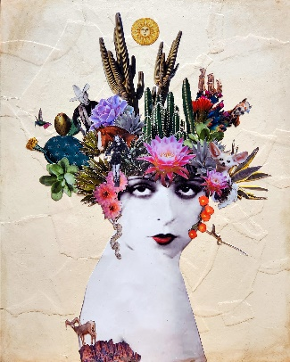 |  |  |  |  | Laura Gruici  - Glendale, AZ | 623 241-2294 | lauragruiciart@gmail.com | https://lauragruiciart.com l https://laurasmusing.com  Laura Gruici is the owner/artist of Laura Gruici Art based out of Glendale Arizona. Laura has worked with many different mediums including oils, acrylics, mixed media and is now presenting a new medium to her work, collage. This latest work was inspired by the southwestern desert where she was born and raised. Her love of vintage items, desert landscapes, and humor makes-up this new body of work that began in 2023. She is passionate about bringing beauty and originality to her one-of-a-kind artwork.

Experience
2023-current |  |  |  | Laura gruici art  Original Southwest inspired collage and mixed media.  - Featured artist in Van Gogh’s Ear Gallery, Prescott AZ.  - Selected by a jury to appear in the Sedona Arts Center Contemporary Surrealism display.  Artwork was selected and appeared on all event posters.  - Exhibited in the ASU Gammage Performing Arts Theatre – extended due to patron feedback.  - Featured in a 2 person show at the Alwun House entitled Human Collage.  - One of the featured artists in the virtual gallery Greater Phoenix Economics Council.
2015-current |  |  |  | Laura’s musing  Owner of Laura's Musing featuring original artwork printed onto an array of gift and home décor items.  - Seller to both retail and wholesale markets across the US, UK, Australia, Spain, and Germany  - Work has been licensed to Great Art Unlimited to be recreated into figurines selling across a global market.  - Featured in several brick-and-mortar stores across the US.  - Chosen to be featured by Gift Shop Magazine and Smart Retailer Magazine showcasing my greeting card line to retailers.

